Changes from last revision
Date | User | Edits
1/6/2020 | Prof. Levi’s Design Team | USC Release of PTM65 design from GF65 design

Subsystem or block descriptions
Design name | Six-pole 7MHz AAFilter in PTM65nm CMOS
The Top-level cell name | Aafilter_7MHz_PTM65_AllDevices
Designer | Prof. Levi’s Design Team
Organization | University of Southern California

Overview
10 bit linearity Anti-Alias Filter with -3 dB bandwidth of 7 MHz. Originally designed, simulated at 39 PVT corners, fabricated and measured in GF65LPe process.

Block Specifications and Compliance
.
Spec Name | Nominal | Max | Note
DC gain (dB) | -0.004844 | N/A | PTM65 has no process corners. Simulated at available corner, 27C, Vdd=1.2V
f_3dB (MHz) | 7.244 | N/A | PTM65 has no process corners. Simulated at available corner, 27C, Vdd=1.2V
f_50dB (MHz) | 18.33 | N/A | PTM65 has no process corners. Simulated at available corner, 27C, Vdd=1.2V
IM3 from DFT plot (dB) | 66.86 | N/A | PTM65 has no process corners. Simulated at available corner, 27C, Vdd=1.2V
Integrated Output (Input) Noise Voltage 10Hz to 100MHz (uVrms) | 167.10 | N/A | PTM65 has no process corners. Simulated at available corner, 27C, Vdd=1.2V
Power Consumption (mW) | 29.45 | N/A | Bias set by constant current source, see testbench called test_opamp5_PTM65_AllDevices.
Area (mm²) | N/A | N/A | Only Schematic. No Design Rules available for PTM65.
VDD (Volt) | 1.2V | N/A

Block diagram

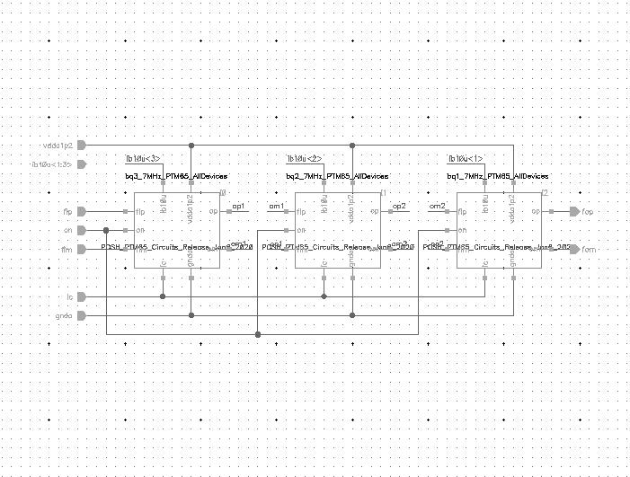
Cascade of three (3) differential-input, differential output opamp-based biquads to realize a six-pole 7 MHz filter. Filter has common-mode and power-down control.

Signal list
Symbol, pins and descriptions.

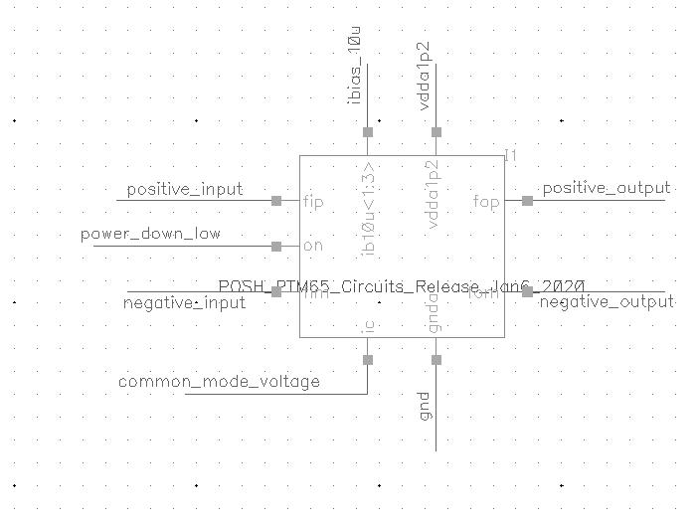
Signal Pins | Direction  (I/O) | Type  (supply, ground, analog current, analog voltage, digital voltage) | Max Voltage  (core, IO or max voltage) | Specification
vdda1p2 | I | Supply | Core | Power Supply, 1.2 V
Gnda | I | Ground | Core | Analog Ground
fip,fim | I | Analog voltage | Core | Differential Analog Input
fop,fom | I | Analog voltage | Core | Differential Analog Output
ic | I | Analog Voltage | Core | Common mode voltage control input
Ib10u<1:3> | I | Analog Current | Core | Bias current bus that is three wires wide.
on | I | Digital Voltage | Core | Power down active low

Design Hierarchy
Symbol, pins and descriptions.
None.

Test Bench
Testbench list, schematics, simulation conditions, simulation results and descriptions.
Cell Name | Note
test_aafilter_7MHz_PTM65_AllDevices | AC test for open-loop gain and phase-margin, DC operating point

Simulations (test_aafilter_7MHz_PTM65_AllDevices):

Conditions | Values
Process corner | TT
Temperature (°C) | 27
VDD (Volt) | 1.2
Input amplitude | Two-tone test using 2.5 MHz and 3 MHz with amplitude 250mV
Input common mode voltage | 0.6V

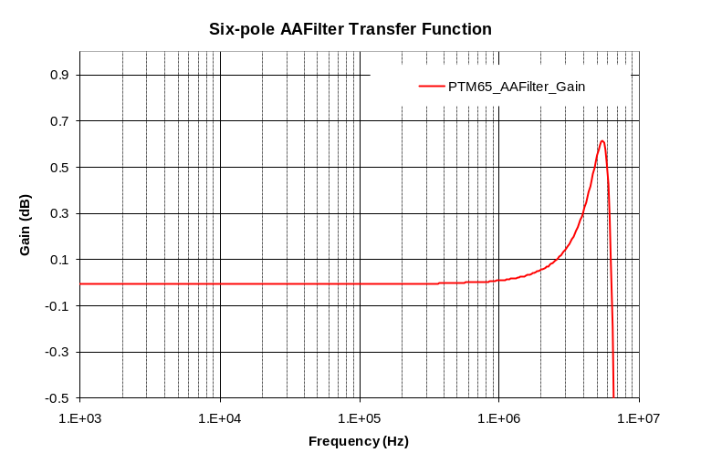
Open-loop gain

Cumulatively Integrated Output (Input) Noise

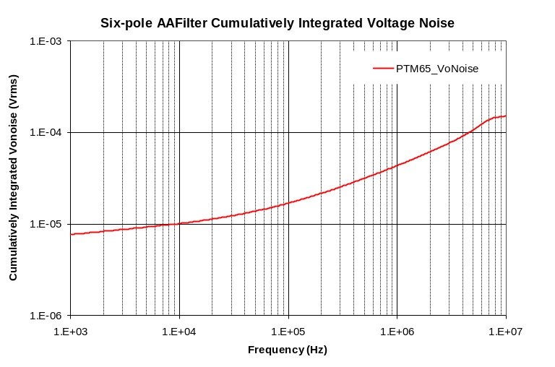

IM3 suppression from DFT
